**Producer consumer problem**, is one of the classic problems of synchronization. Let's start by understanding the problem here, before moving on to the solution and program code.

What is the Problem Statement?

There is a buffer of n slots and each slot is capable of storing one unit of data. There are two processes running, namely, **producer** and **consumer**, which are operating on the buffer.

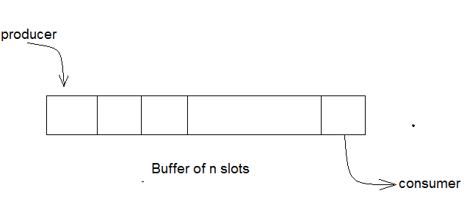

**Bounded Buffer Problem**

A producer tries to insert data into an empty slot of the buffer. A consumer tries to remove data from a filled slot in the buffer. As you might have guessed by now, those two processes won't produce the expected output if they are being executed concurrently.

There needs to be a way to make the producer and consumer work in an independent manner.

Here's a Solution

One solution of this problem is to use semaphores. The semaphores which will be used here are:

* m, a **binary semaphore** which is used to acquire and release the lock.
* empty, a **counting semaphore** whose initial value is the number of slots in the buffer, since, initially all slots are empty.
* full, a **counting semaphore** whose initial value is 0.

At any instant, the current value of empty represents the number of empty slots in the buffer and full represents the number of occupied slots in the buffer.

The Producer Operation

The pseudocode of the producer function looks like this:

do

{

// wait until empty > 0 and then decrement 'empty'

wait(empty);

// acquire lock

wait(mutex);

/* perform the insert operation in a slot */

// release lock

signal(mutex);

// increment 'full'

signal(full);

}

while(TRUE)

* Looking at the above code for a producer, we can see that a producer first waits until there is atleast one empty slot.
* Then it decrements the **empty** semaphore because, there will now be one less empty slot, since the producer is going to insert data in one of those slots.
* Then, it acquires lock on the buffer, so that the consumer cannot access the buffer until producer completes its operation.
* After performing the insert operation, the lock is released and the value of **full** is incremented because the producer has just filled a slot in the buffer.

The Consumer Operation

The pseudocode for the consumer function looks like this:

do

{

// wait until full > 0 and then decrement 'full'

wait(full);

// acquire the lock

wait(mutex);

/* perform the remove operation in a slot */

// release the lock

signal(mutex);

// increment 'empty'

signal(empty);

}

while(TRUE);

The consumer waits until there is atleast one full slot in the buffer.

Then it decrements the **full** semaphore because the number of occupied slots will be decreased by one, after the consumer completes its operation.

After that, the consumer acquires lock on the buffer.

Following that, the consumer completes the removal operation so that the data from one of the full slots is removed.

Then, the consumer releases the lock.

Finally, the **empty** semaphore is incremented by 1, because the consumer has just removed data from an occupied slot, thus making it empty.

**Dining philosopher problem**

# Dining Philosophers Problem

The dining philosophers problem is another classic synchronization problem which is used to evaluate situations where there is a need of allocating multiple resources to multiple processes.

### What is the Problem Statement?

Consider there are five philosophers sitting around a circular dining table. The dining table has five chopsticks and a bowl of rice in the middle as shown in the below figure.

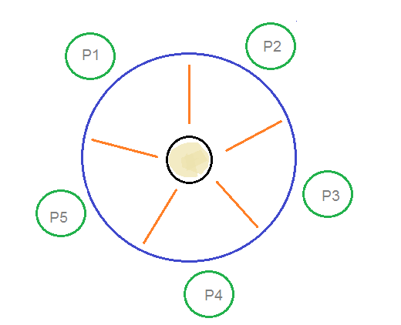

**Dining Philosophers Problem**

At any instant, a philosopher is either eating or thinking. When a philosopher wants to eat, he uses two chopsticks - one from their left and one from their right. When a philosopher wants to think, he keeps down both chopsticks at their original place.

## Here's the Solution

From the problem statement, it is clear that a philosopher can think for an indefinite amount of time. But when a philosopher starts eating, he has to stop at some point of time. The philosopher is in an endless cycle of thinking and eating.

An array of five semaphores, stick[5], for each of the five chopsticks.

The code for each philosopher looks like:

while(TRUE)

{

wait(stick[i]);

/*

mod is used because if i=5, next

chopstick is 1 (dining table is circular)

*/

wait(stick[(i+1) % 5]);

/* eat */

signal(stick[i]);

signal(stick[(i+1) % 5]);

/* think */

}

When a philosopher wants to eat the rice, he will wait for the chopstick at his left and picks up that chopstick. Then he waits for the right chopstick to be available, and then picks it too. After eating, he puts both the chopsticks down.

But if all five philosophers are hungry simultaneously, and each of them pickup one chopstick, then a deadlock situation occurs because they will be waiting for another chopstick forever. The possible solutions for this are:

A philosopher must be allowed to pick up the chopsticks only if both the left and right chopsticks are available.

Allow only four philosophers to sit at the table. That way, if all the four philosophers pick up four chopsticks, there will be one chopstick left on the table. So, one philosopher can start eating and eventually, two chopsticks will be available. In this way, deadlocks can be avoided.